**Objectives:**

1. To be familiar with syntax and structure of C-programming.
2. To learn problem solving techniques using C.
3. To find errors and correct them.

**Programs:**

Find out the errors and output of the following program.

**Code:**

// Following codes are written and compiled in DevC++

**Error1:**

#include<stdio.h>

int main(){

int i,j,rows;

printf("enter the no of rows:");

scanf("%d",&rows);

for(i=1;i<=rows;++i)

{

for(j=1;j<=i;++j){

printf("*");

}

printf("\n");

}

return 0;

}

**Output:**

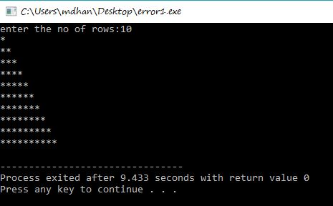

**Error2:**

#include<stdio.h>

int main()

{

int n,r,c;

printf("enter the no of rows:");

scanf("%d",&n);

for(r=1;r<=n;r++)

{

for(c=1;c<=n;c++)

{

printf("*");

}

printf("\n");

}

return 0;

}

**Output:**

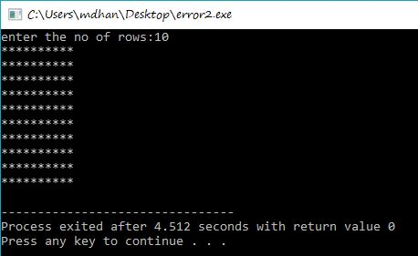

**Error3:**

#include<stdio.h>

int main()

{

int i,j;

for(i=1;i<=5;i++)

{

for(j=i;j>=1;j--)

{

printf("%d",j);

}

printf("\n");

}

return 0;

}

**Output:**

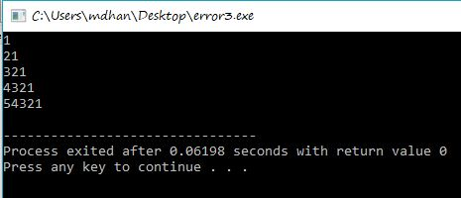

**Error4:**

#include<stdio.h>

int main()

{

int var1,var2;

printf("input the value of var1:");

scanf("%d",&var1);

printf("input the value of var2:");

scanf("%d",&var2);

if(var1 !=var2)

{

printf("var1 is not equal to var2 \n");

//nested if else

if(var1>var2)

{

printf("var1 is greater than var2\n");

}

else

{

printf("var2 is greater than var1\n");

}

}

else

{

printf("var1 is equal to var2\n");

}

return 0;

}

**Output:**

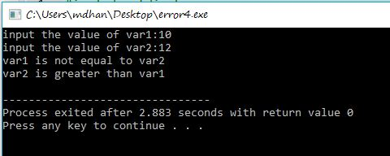

**Discussion and conclusion:**

This is the 1st code where we find errors of the programs. The program is focused on finding the errors.

**Error1:**

* We found that there should have ‘;’before scanf.
* We cannot write Pritnf. The word printf should be in small letter.

**Error2:**

* Stdio.c ( no such directory). We correct them by replacing c with h,so the final directory was stdio.h
* ‘$n’ undeclared. C programming doesn’t use $ for scanf function instead it uses’&’ for scanf.
* ‘r ‘ and ’ c’ was undeclared. So, we 1st declared ‘r’ and ‘c’ as a variable.
* ‘return’ with value ,in function returning void. So we replace the void main with int main.

**\*Error3 and Error 4 was error free**

From this lab, I understood the basic structure of C programming finding out different errors in code/program. Hence, all the errors were corrected and correct output was placed after each code.